|  |
| --- |
| Low Poly Modeling |
| Box Modeling the Head |
| Epona Schweer, AIE, 2010 |

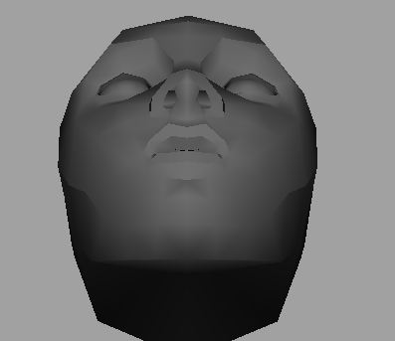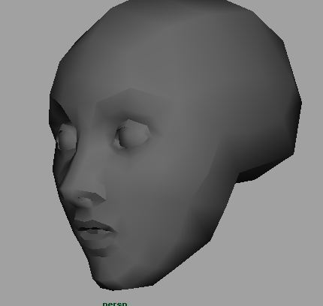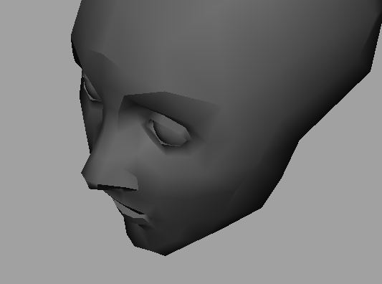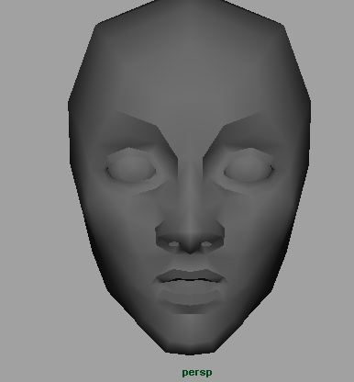

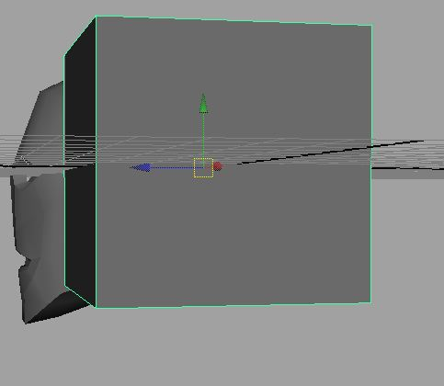

As with all things in life...it starts with a cube

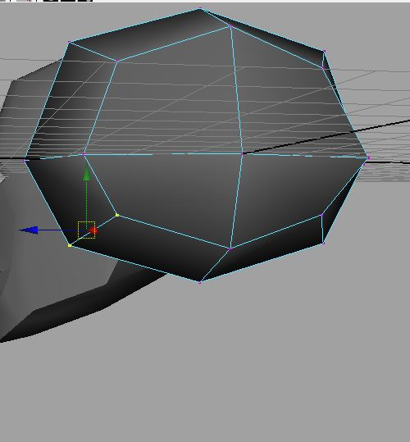

Subdivide it (in Maya that’s Mesh>Smooth using default settings)

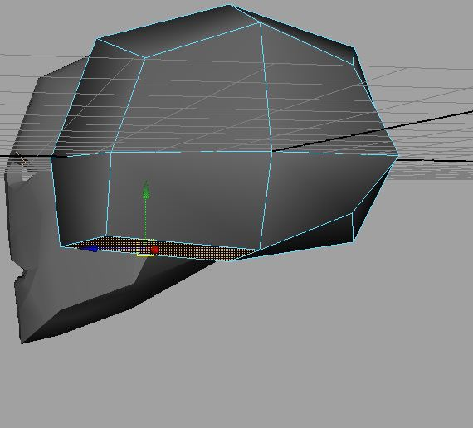Start by adjusting the front of your smoothed cube to look like a skull. Then bring the verts on the bottom of the front of the face forward (forming a line that will go from just above the ear, across the top of the cheekbone, under the eye and across the bridge of the nose).

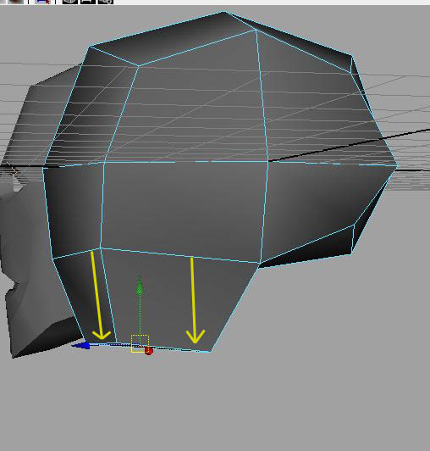

Select the faces in the front of the face...go on...do it...I dare you

Extract said faces, pull it down to just below mouth level and scale in (Side = mouth to back corner of jaw. Front = width of jaw)

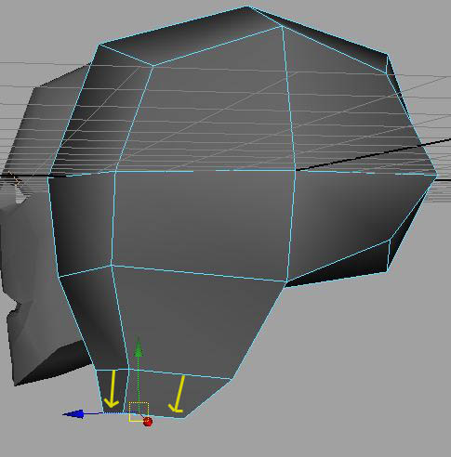

Now do it again!

This time extract down to the end of the chin. Scaling/Rotating/Moving to make it chin-like.

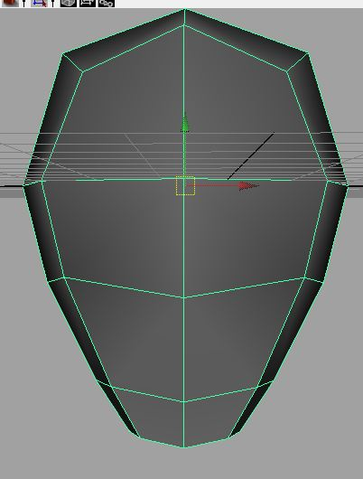

Take this time to adjust geometry to make it more head like. Be careful to keep your loops clean and tidy.

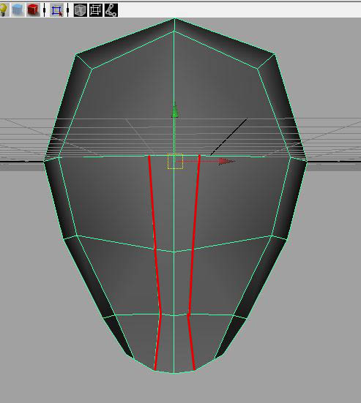

Time to start splitting faces!

Make a split from the inside corner of the eyebrow, down the bridge of the nose and through the high points of the lips, and down to the inside corners of the chin.

(This is the perfect time to cut your face in half and create an instance, so you only have to work on half the face)

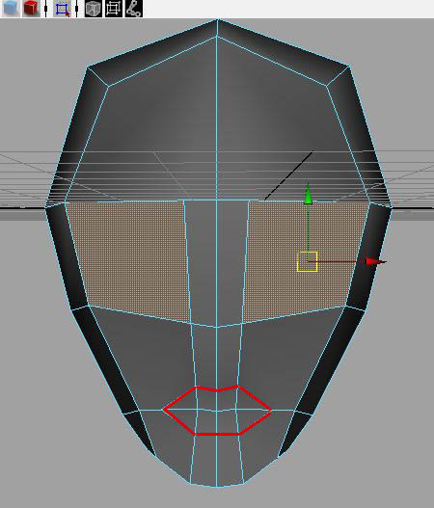* Yes that’s an N-gon. I plan on coming back to clean up after I’m done modelling!

Use those first splits as the upper points and underside of the lips. Split around the mouth/jaw edgeloop to create the outline of the mouth.

Now, select that face half way down the front of your head that looks PERFECT for an eye extrusion

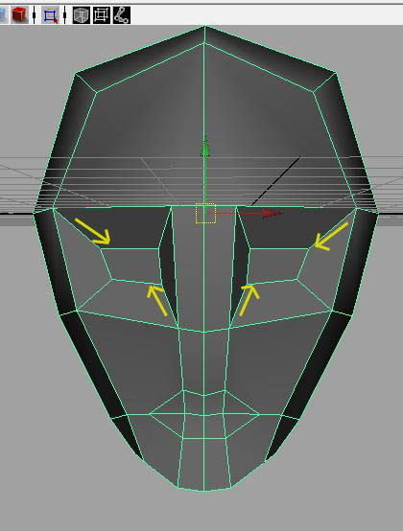

...and extrude in! Scale it in to roughly eye-size, then push those eyeshapes slightly into the head (you know, kinda like how eyes are inset into the face 8P)

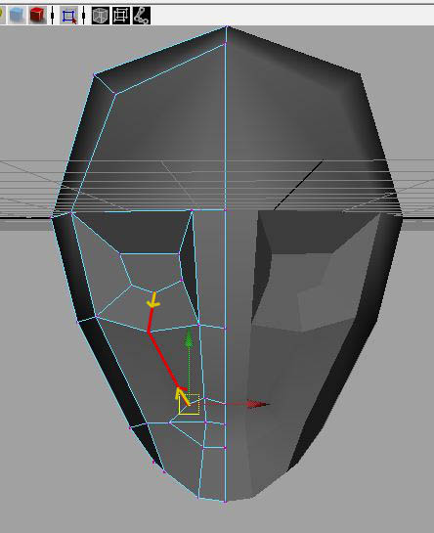

Make new splits from the bottom of the eye to the corner of the upper lip

You’ll have to adjust the new vertices you’ve created so your edge loops capture the flow of facial features (as opposed to straight lines)

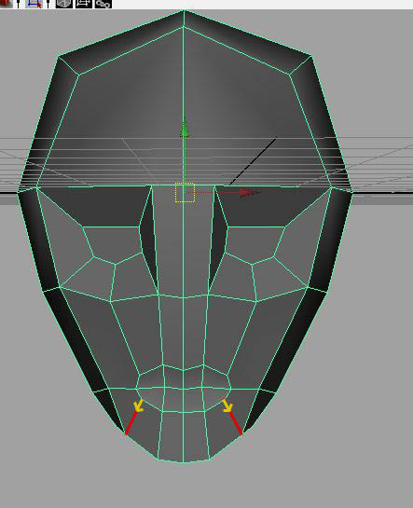

Split from the outside corner of the chin into the corner of the lower lip

(Again adjusting verts to capture flow of facial features)

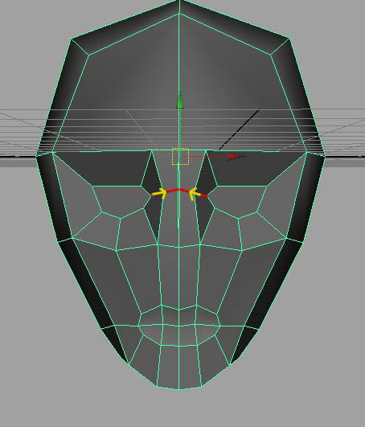

Split from the inside corner of the eye and across the bridge of the nose

(Again adjusting verts to capture flow of facial features)

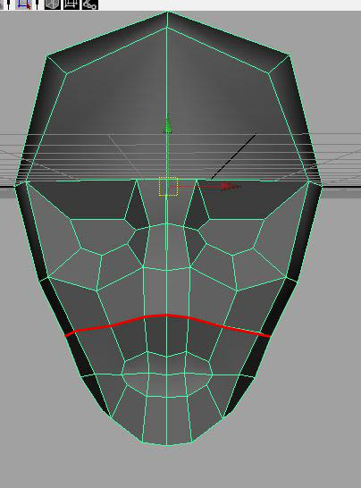

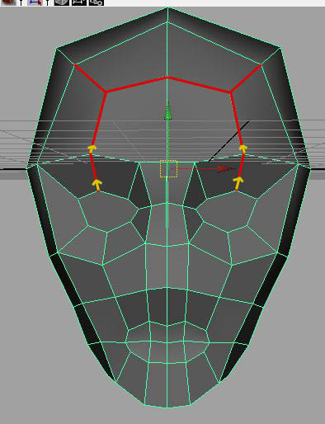The next split goes from upper jaw (just below the ear), through the cheek cavity and across the tip of the nose

Split from the top of the eye up and across the forehead. Closing off those new forehead faces into the corners of the brow-line

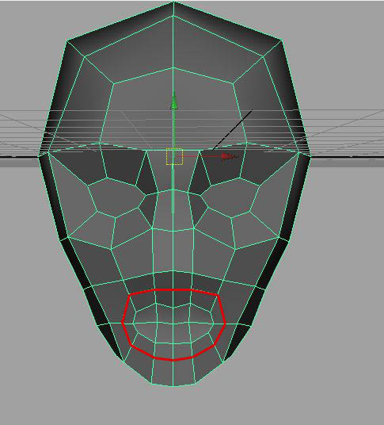

Split a ring around the mouth. This is to simulate those cool facial muscles that make smilies and frowns possible.

Keep even spacing between your edge loops (loops shouldn’t be too close together at this stage)

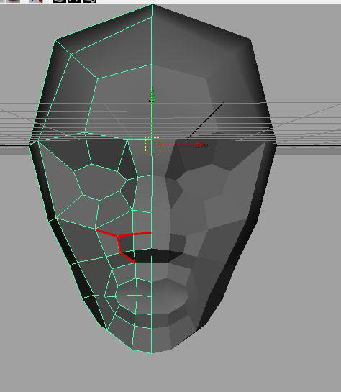

Time to split in the nose. Use the top of the outside mouth loops you created in the last step as the bottom of your nose loop.

Clever huh?

Just cut a triangle from the bottom corner of the nose, then up the side of the nostril, then across the top of the bulb of the nose

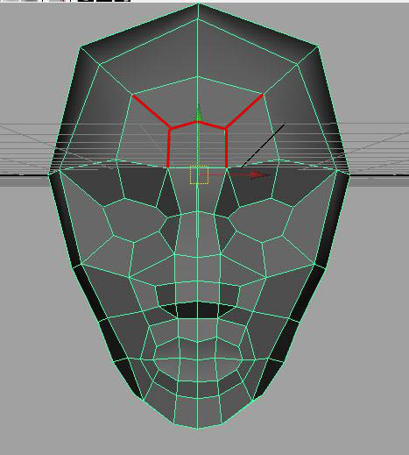

I like to finish up the forehead at this point with my scowl square. You know, that square of bunched up skin between our eyebrows and above our nose that gets created when we scowl (it’s so cute then that happens!)

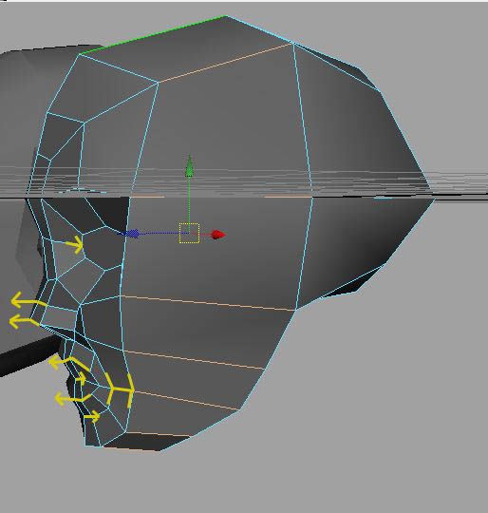

We’ve mostly been working in front view at this point, so take some time to clean up your side view.

Do NOT add any more detail! Just adjust the verts you already have and scoot them back in the face to capture that 3D Profile (our faces are obviously not flat, but wrap around our skulls)

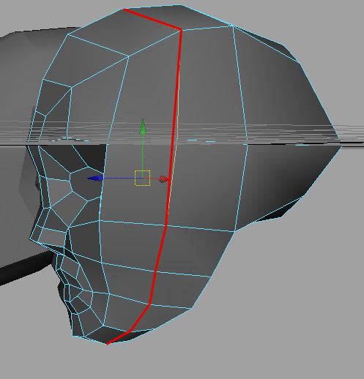I felt like I needed another edge loop down the side of the face to round out those features

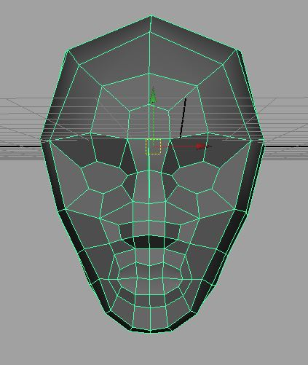I probably could have shifted the verts that run down the side of my forehead, eye and cheek in a bit to achieve a similar result with fewer poly’s though.

If I need to go back and reduce poly’s, this will probably be the first loop I cut

This is what we’ve got so far.

Again, stop to make sure that all your verts are working for you (not just sitting there all lazy like while they make two or three verts do the work that one could do!)

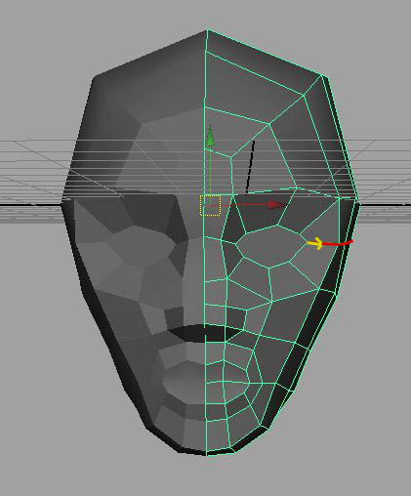

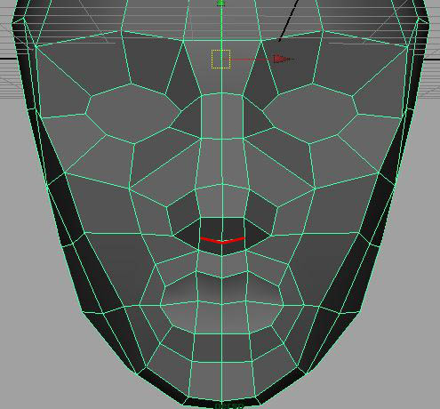Split from the outside corner of the eye, across the top most point of the cheek bones ending at mid-ear

Split between the nostril triangles.

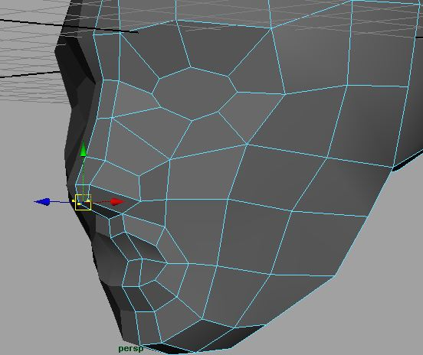

Work those verts!

Pull them forward and scale them in slightly to form the bottom tip of the nose (creating room for us to extrude our nostrils in)

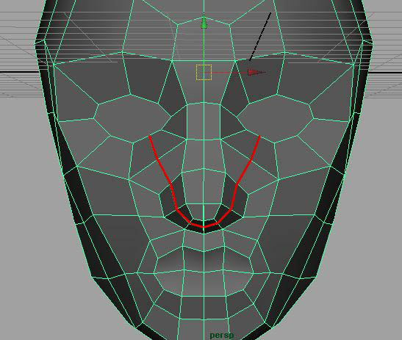

Split from the lower inside corner of the eye, through where the widest point of the nose bridge meets the inside of our cheek bone, down the front of the nostril and across that fleshy extension below the nose.

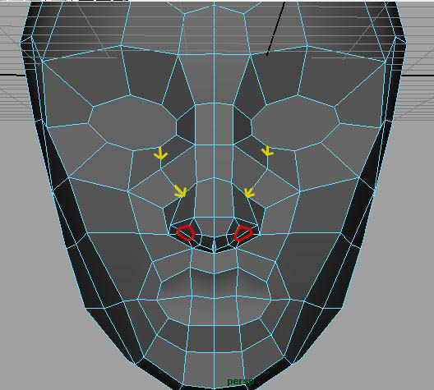

Take a moment to work the verts you added in the last step.

Now, select those two faces that look like they’d be the PERFECT place to extrude a nostril...

...and extrude in for the outline of your nostril!

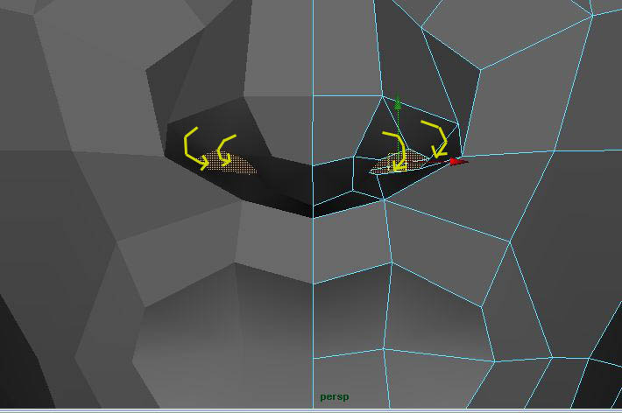

I find that you can get a lot out of an edge loop when you play with that extrusion’s rotations.

Rotating that extrusion clockwise, then down, helps emphasise the shape of the nostrils

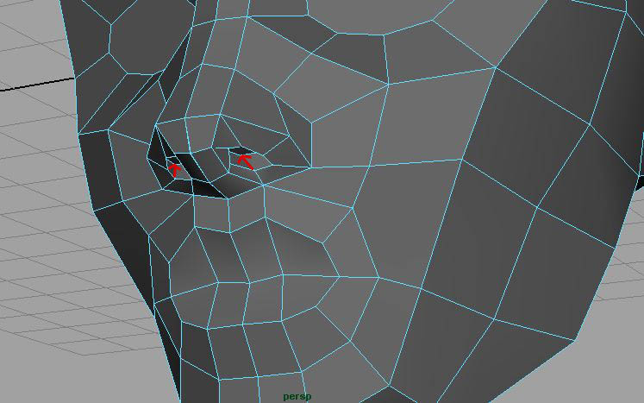

One final extrusion up into the nose will complete our lovely lovely nostrils!

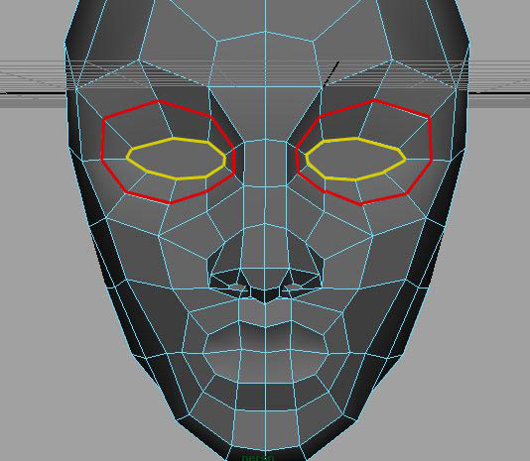

Before we add an edge loop to help define the bone around the eye, take a moment to adjust the verts you already have to shape the outline of the eyelids

Split a ring around the eye, keeping even spacing (much in the same way that we defined the area around the mouth)

Adjust, adjust, adjust!

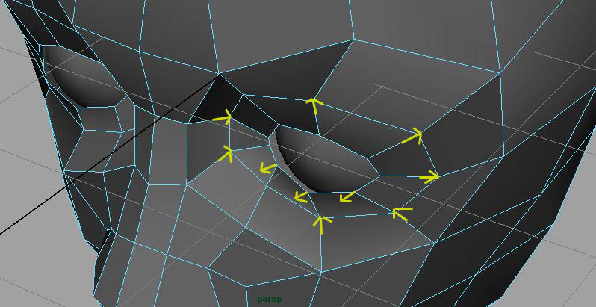Add a sphere to help you visualise where the eyelids will sit on top of the eyeball (keep room for the thickness of the lid)

Work those verts and use REFERENCE if you want this to look right!

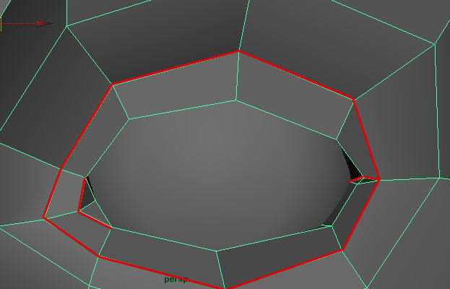

Now make a split for eyelid, where it sinks into the face at the top and bottom of the eyeball.

I like to add triangles at the corners of the aye at this point to visually separate the eyelids

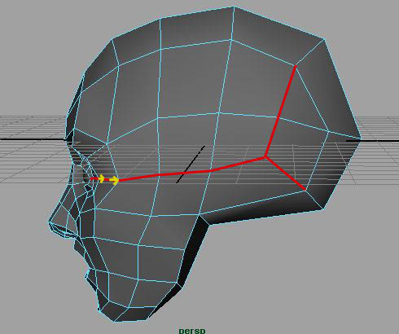

Taking a break to close up N-gons and make sure my verts are doing what they need to be doing (never add detail when you can put what you have already to work for you!)

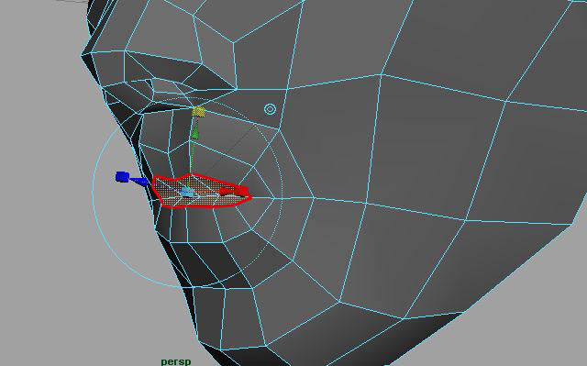

Nearing the end now

Let’s finish up the lips

Extrude the faces of your mouth in, scaling and rotating so that it forms the bottom of your upper lip and top of your lower lip respectively.

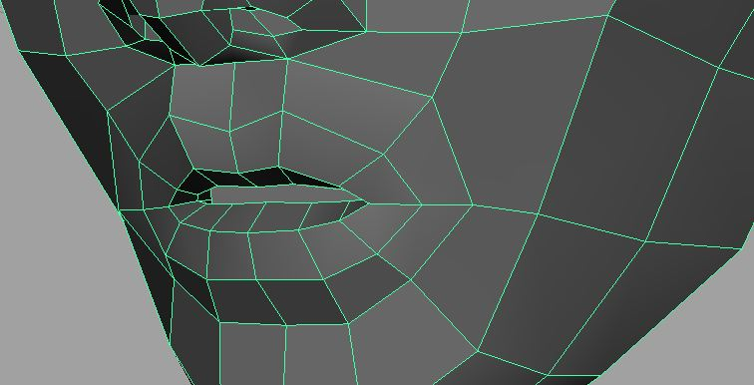

Extrude once more to form the inside of the lips

Extrude a final time into the face and scale up to hint at the walls on the inside of the mouth

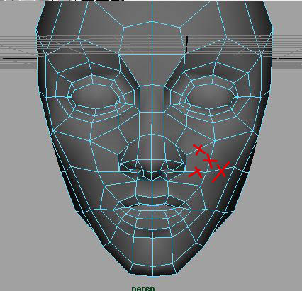

Retopology time!

I want a loop running from the bridge of the nose down the side of the mouth so I get that cool fold at the check when I smile.

To make room for that, I delete some edges, knowing that I’ll create new ones soon

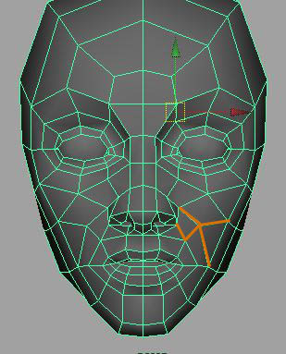

Soon as in NOW!

I split in my new edges so I get that cool fold of flesh down from the bridge of the nose to the dimple in the cheek

This creates an awesome triangle at the cheekbone, which will emphasise the bone being so close to the surface of the skin

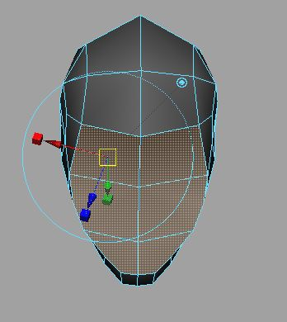

Now to create a shelf that emphasises the jaw line and the base of the skull

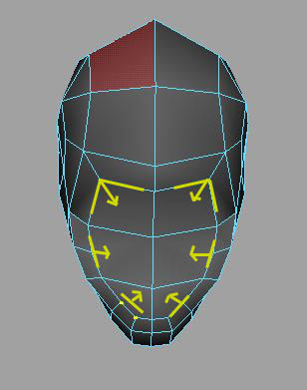

Select the faces on the underside of the head and extrude them in

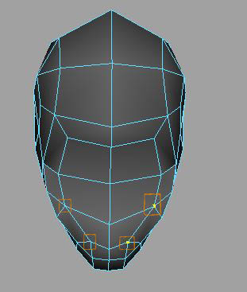

Before moving forward with the neck, take a moment to reduce some of the geometry at the base of the head (which will soon be the top of our neck). You can merge the verts at the corners of the chin and the corners of the jaw, letting your newly made triangles emphasis those features

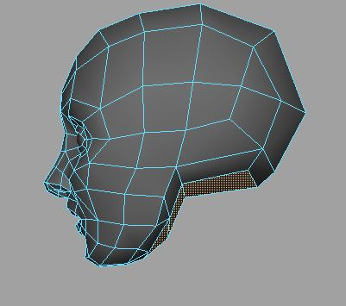

Lets create the neck

Start by selecting the faces at the base of the head

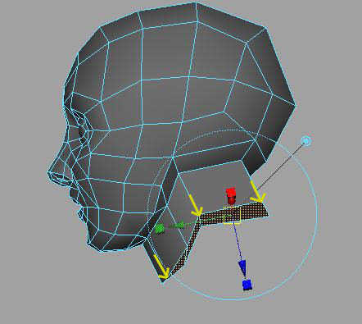

Extrude those down to about mid-neck (use global extrusion as opposed to local extrusion, so it doesn’t flare out)

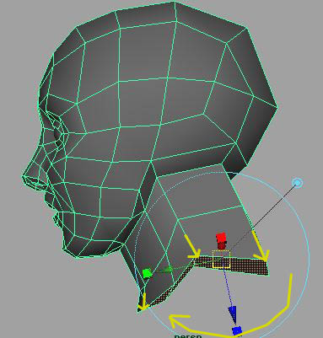

Extrude a second time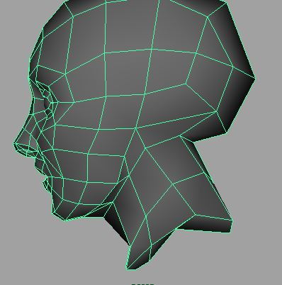 to create the base of the neck. Rotating and scaling so that it captures the muscles that stretch between the neck and the shoulders

Take a moment to put those newly created verts to work for you and adjust those extrusions to look neck-like. USE REFERENCE!!

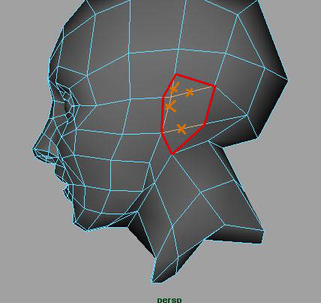

Time to create the ear! An ultra low poly ear where most of the detail will come through in the texture

Start by splitting around the outline of the ear (up the corner of the jaw, behind the back of the cheekbones, keeping the top of the ear on level with the eyebrows)

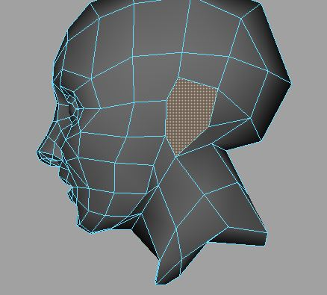

Delete any edges on the inside of that ear outline to give you a clean ear-shape to extrude from

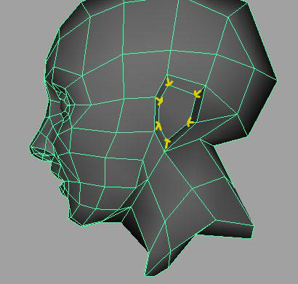

Extrude that ear, scaling slightly and pulling out from the side of the head just enough to show the extension of the ear from the skull.

Rotate that extrusion so that the back of the ear pulls away from the head, and the front of the ear sits closer to it (kinda like...you know...a real ear 8P)

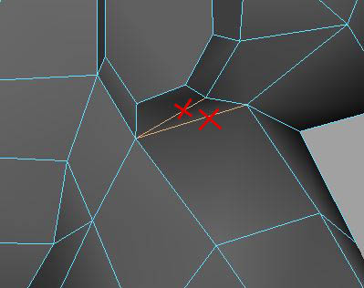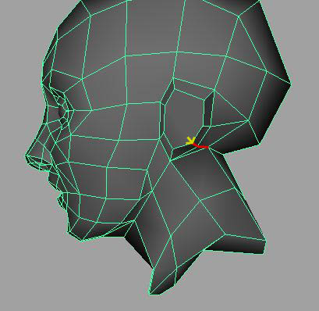

Split from the lower right corner of the ear to the base of the head

Spend some time shaping the vertices you have already to make them more ear-like

Retopology time!

Get rid of the edges at the base of the ear to make room for new edge flow

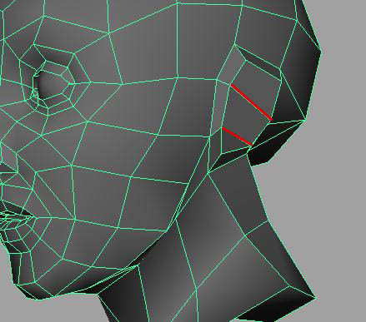

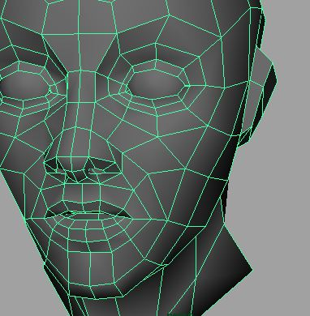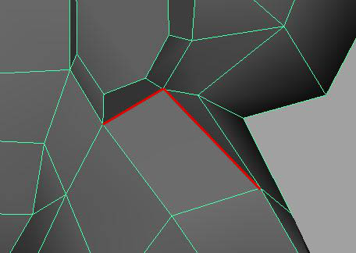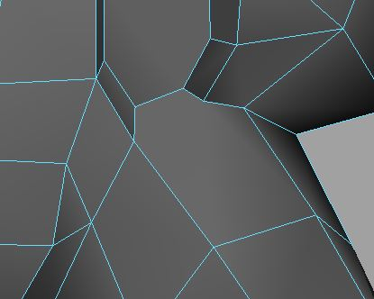

Take the time to spin around your head, reviewing it from all angles. The edge loops have a very specific purpose and should look like they’re doing what they’re meant to be doing at all angles.

How do you know what they’re meant to be doing? Study reference for what it is you’re trying to create! Always work from real world reference so you’re not just regurgitating the design decisions of another artist

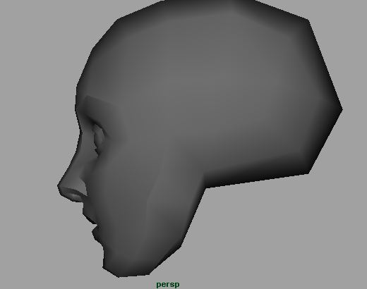

Almost done!

Clean up your mesh (no N-Gons, holes, floating verts, etc)

At this point I like to Soften Normals all over, then selectively Harden Normals where I want to emphasis certain facial features.

My favourites are:

- From bridge of nose along the top of the brow

- Top of the upper eyelid

- Inside corner of the eye cavity

- Inside and outside loop around the nostrils

- Cleft of the nostril where it meets the cheek

- Down the outside of the cheekbones

- Along the jawline

- Across the top and bottom of both lips

- Cleft of the chin

Experiment and find your own!

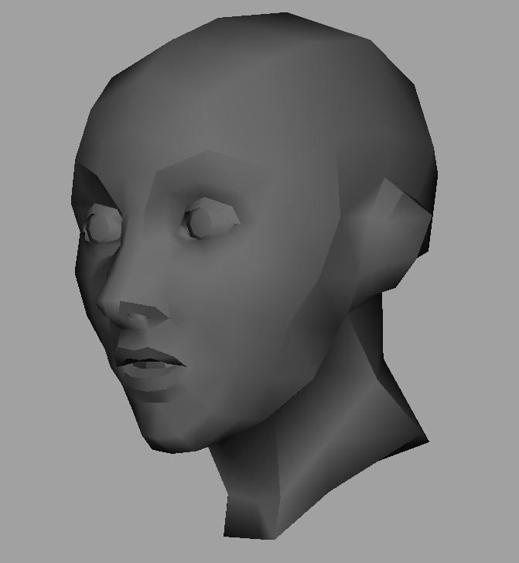

There you have it.

One low poly head, ready for texturing 8)